 | 7.3.1 Editors - 3D Viewport - Sidebar - Item tab
Table of content
Item tab - Transform Panel 4
Animate Property 4
Keyframe and Driver coloring 4
Location 4
Rotation 4
Rotation Mode 4
Quaternion 4
Scale 5
Dimensions 5
Right Click menu 5
Insert Keyframe 5
Insert Single Keyframe 5
Add Driver 6
Driver Settings 6
Type 6
Built-in functions (Average, Sum, Min and Max) 6
Custom (Scripted Expression) 6
Driver Value 6
Expression 6
Expression edit box 6
Use Self 6
Driver Variables 7
Add Input variable 7
Driver Variable panel 7
Variable type 7
Object 7
Type 7
Space 7
Value 7
Update Dependencies 7
Show in Drivers Editor 7
Open Drivers Editor 8
Add All to Keying Set 8
Add single to Keying Set 8
Remove from Keying Set 8
Reset All to Default Value 8
Reset Single to Default Value 8
Unset 8
Copy All to Selected 8
Copy Single to Selected 8
Copy Data Path 9
Copy as new Driver 9
Assign Shortcut 9
Online Python Reference 9
Edit Source 9
Replace Keyframes 9
Replace single Keyframe 9
Delete Keyframes 9
Delete Single Keyframe 9
Clear Keyframes 9
Clear single Keyframe 9
Delete Drivers 9
Delete Single Driver 9
Copy Driver 10
Edit Driver 10
Item tab - Transform Panel in Edit Mode 10
Mesh Objects 10
Median 10
Global / Local 10
Vertices Data 10
Mean Bevel Weight 10
Edges Data 10
Mean Bevel Weight 10
Mean Crease 10
Curve Objects / Surface Objects 10
Median 10
Global / Local 11
Mean Weight 11
Mean Radius 11
Mean Tilt 11
Metaball Objects 11
Median 11
Global / Local 11
Radius 11
Stiffness 11
Type 11
Text Objects 11
Armature objects Edit Mode 12
Head 12
Radius 12
Tail 12
Radius 12
Roll 12
Length 12
Envelope 12
Lattice Objects 12
Vertex 12
Global / Local 12
Mean Weight 12
Item tab - Transform Panel in Pose Mode 13
Armature Objects in Pose Mode 13
Item tab - Vertex Weights Panel 13
Filter Vertex Groups 13
Group 13
Weight 13
Paste Weight to Selected 13
Delete Weight 13
Normalize 14
Copy 14

Item tab - Transform Panel
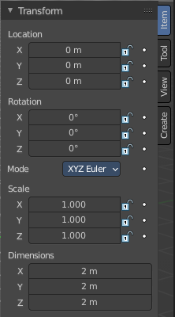
When you add an object to the scene then the Item tab with the Transform panel becomes visible. The content changes, dependent of the object type. And it changes with the mode.
In general you will most of the time see the same content though. Location, Rotation, Scale and Dimension.

Animate Property
The properties with a dot button behind can be animated.

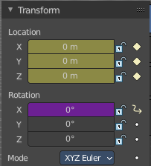
Keyframe and Driver coloring
When a keyframe exists at the current position, then the corresponding edit box turns yellow. When a driver exists at the current position, then the corresponding edit box turns purple.
Note that you can have either a driver or a keyframe. Both is not possible.

Location
The current location of the object in its X, X and Z axis. The lock button behind the edit boxes allows you to lock the values.

Rotation
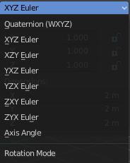
The current rotation of the object in its X, X and Z axis in world coordinates. The lock button behind the edit boxes allows you to lock the values.

Rotation Mode
Adjust what method gets used for the rotation. Euler rotation can run into a so called Gimbal lock, which can be avoided with quaternion rotation mode. But for most cases the default XYZ Euler method should work.

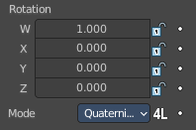
Quaternion
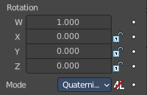
With euler angles you will have three values available. But with a quaternion you will have four values available. And quaternions reveals a 4L button. This button shows or hides a lock behind the W value. Normally a quaternion has just three locks, one for each of the single axis. The W value is a mathematical construct from the three object axis. And you usually neither want to edit it nor to lock it therefore.
Locking the W axis will lock all axis.

Scale
The current scale of the object in its X, X and Z axis in world coordinates. The lock button behind the edit boxes allows you to lock the values.
Scale is not dimensions. Your object can have a scale of 1 in world coordinates. But a dimension of 4.5. Note that for some operations it is required to have a scale of 1 to get some operations to work. This can be achieved with applying scale in the Object menu.

Dimensions
The current dimension of the object in its X, X and Z axis in world coordinates. The lock button behind the edit boxes allows you to lock the values.
The Dimensions edit boxes are just available for primitives objects. Objects like Empties or a Camera doesn't have a dimension, but a scale factor.

Right Click menu
Location, Rotation and Scale edit boxes and the locks have a right click menu with further functionality.
When there is already a keyframe available then the right click menu looks a bit different. Same counts for adding a driver first.
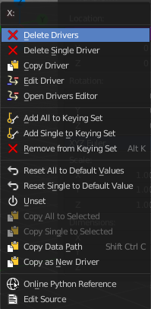
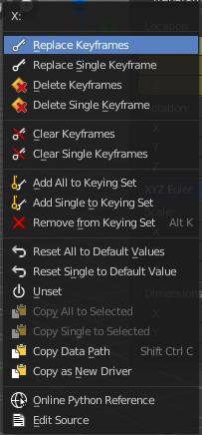
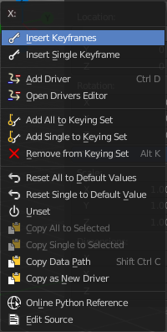

Insert Keyframe
Inserts a keyframe at the current position. The keyframe type depends of where you right click. Insert Keyframe adds a keyframe for all axis.

Insert Single Keyframe
Inserts a keyframe at the current position. The keyframe type depends of where you right click. Insert Single Keyframe adds a keyframe for just the current axis.

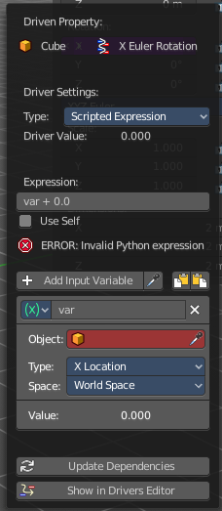
Add Driver
In Bforartists lots of things can be animated. Also buttons. Add Driver does exactly what it tells. It adds a driver for animation needs to the element. Drivers allows to control animation by properties like expressions, scripts or movements of other objects. Drivers are explained in the chapter 18 Editors - Drivers.
When you click the button the Driven Property panel will appear where you can change the properties for this driver. You don't need to confirm the driver creation. It is just further settings.

Driver Settings

Type
The Driver type. There are two categories of drivers. Built-in and Custom

Built-in functions (Average, Sum, Min and Max)
The driven property will have the value of the average, sum, lowest or highest (respectively) of the values of the referenced Driver Variables. If there is only one driver variable, these functions will yield the same result.

Custom (Scripted Expression)
An arbitrary Python expression that can refer to the Driver Variables by name.

Driver Value
The current result of the driver setup.

Expression

Expression edit box
Add a custom expression. An Expression to use for scripted expression.
The expression has access to a set of standard constants and math functions provided in the Driver Name space. For an example of adding a custom function to the name space.
When the expression is invalid then you get an error message. This error message appears also with the default values. Just ignore.

Use Self
The variable self can be used for drivers to reference their own data. This is useful for objects and bones to avoid having creating a Driver Variable pointing to itself.
Example: self.location.x applied to the Y rotation property of the same object will make the object tumble when moving.
Note that dependencies for properties accessed via self may not be fully tracked.

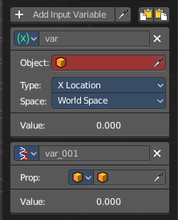
Driver Variables
Driver Variables are references to properties, transformation channels, or the result of a comparison between transformations of two objects. It is displayed by a panel with all necessary settings, which gets filled in automatically when you create the driver.

Add Input variable
Add manually a new driver variable.
Picker should allow you to pick a target object. But this is dysfunctional here since the panel closes immediately when you move the mouse out of it. Please use the picker in the Driver Editor.
Copy and Paste buttons allows you to copy and paste Driver variable panels.

Driver Variable panel

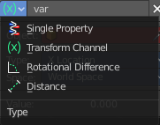
Variable type
The content of the Driver variable panel changes, dependent of the variable type that you choose here. We came from the transform panel, so our default type here is transform channel. That's what we will explain here.

Object
Our object type.

Type
The type of the driver.

Space
The transform space in which the transform should happen.

Value
The resulting value of the driver.

Update Dependencies
Update all dependencies.

Show in Drivers Editor
Opens the Drivers editor in a floating window. The drivers editor is explained in the chapter 18 Editors - Drivers.

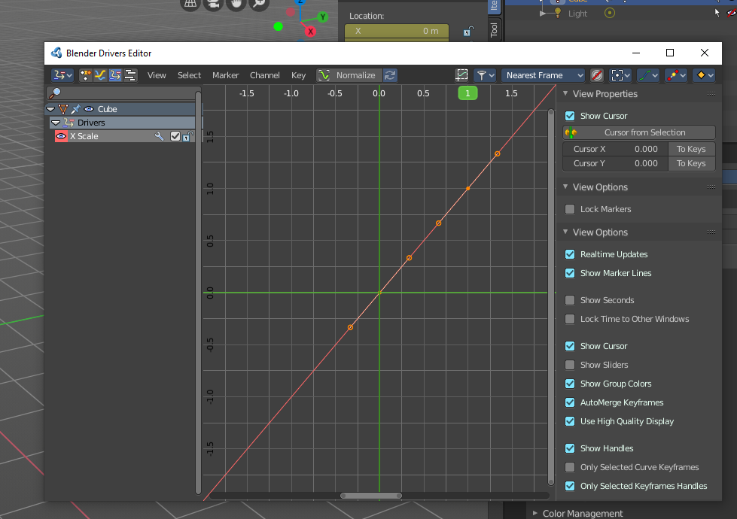
Open Drivers Editor
Opens the Drivers editor in a floating window. The drivers editor is explained in the chapter 18 Editors - Drivers.

Add All to Keying Set
Add All to Keying Set adds the information of the element to the current keyframe.

Add single to Keying Set
Add to Keying Set adds the information of the element to the current keyframe.

Remove from Keying Set
Remove from Keying Set removes the information of the element from the current keyframe.

Reset All to Default Value
Resets the X Y and Z values to the default value.

Reset Single to Default Value
Resets the value for the single edit box under the mouse to the default value.

Unset
Unset is usually a RMB menu entry when you right click at an edit box. It is somehow similar to Reset to Default Value. But it clears the property instead of resetting it to the default value. Which can end in another value.

Copy All to Selected
Allows to copy the current rotation of all axis to another object.
Workflow. Select target object, hold down shift, select source object, and use Copy All to Selected.

Copy Single to Selected
Allows to copy the current rotation of the single selected axis to another object.
Workflow. Select target object, hold down shift, select source object, and use Copy All to Selected.

Copy Data Path
Copy Data Path copies the RNA data path for this property.

Copy as new Driver
Copies the current value as a new driver.

Assign Shortcut
This is just for the locks. Here you could assign a shortcut.

Online Python Reference
Developer feature. Open the Blender Python Reference.

Edit Source
Developer feature. When you have a text editor open in the current layout then you can call the UI script that contains this menu item.

Replace Keyframes
Replaces the keyframes in all axis at the current position.

Replace single Keyframe
Replaces the keyframe in the currently selected axis at the current position.

Delete Keyframes
Deletes the keyframes in all axis at the current position.

Delete Single Keyframe
Deletes the keyframe in the currently selected axis at the current position.

Clear Keyframes
Deletes all keyframes for all axis.

Clear single Keyframe
Deletes all keyframes for the currently selected axis.

Delete Drivers
Deletes the drivers for all axis.

Delete Single Driver
Deletes the drivers for just the current axis.

Copy Driver
Copies the driver.

Edit Driver
Opens the Driven Property panel where you can change the settings for this driver.

Item tab - Transform Panel in Edit Mode

Just primitive objects like mesh and curve does have an edit mode. Non primitive objects like a camera or an empty doesn't have an edit mode. With two exceptions. Text and Force Field type Curve Guide. Both are curve types.
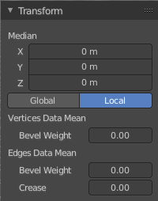

Mesh Objects

Median
Median is the position of the selected mesh part.

Global / Local
Define if the orientation of the selection is local to the selected object, or global to the world coordinates.

Vertices Data

Mean Bevel Weight
Adjust the bevel weight for the selected vertices when you have a bevel modifier at the mesh.

Edges Data

Mean Bevel Weight
Adjust the bevel weight for the selected edges when you have a bevel modifier at the mesh.

Mean Crease
Adjust the weight of the selected vertices when you have a subdivision surface modifier at the mesh.

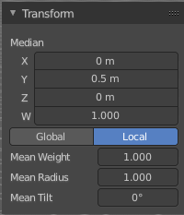
Curve Objects / Surface Objects

Median
Median is the position of the selected mesh part

Global / Local
Define if the orientation of the selection is local to the selected object, or global to the world coordinates.

Mean Weight
Adjust the weight used by softbody. Needs softbody.

Mean Radius
Adjust the radius of the curve control points

Mean Tilt
Adjust the tilt of the curve control points.

Metaball Objects

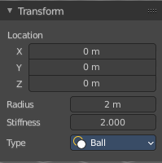
Median
Median is the position of the selected mesh part

Global / Local
Define if the orientation of the selection is local to the selected object, or global to the world coordinates.

Radius
Adjust the radius of the selected meta element.

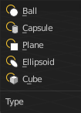
Stiffness
Adjust the stiffness of the selected meta element.

Type
Type is a drop down box. Adjust the meta element type.

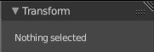
Text Objects
Text objects do have an edit mode, but they don't show content in the Transform panel.

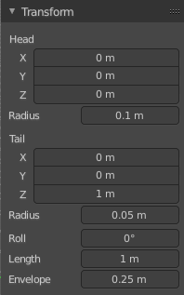
Armature objects Edit Mode
Bones do have a head and a tail. You cannot position the whole bone by numeric values, but the head and tail joints.

Head
Adjust the world position of the head joint.

Radius
This is just useful when you use Envelopes type bones. Adjust the Envelope radius of the head joint.

Tail
Adjust the world position of the tail joint.

Radius
This is just useful when you use Envelopes type bones. Adjust the Envelope radius of the tail joint.

Roll
Adjust the bone roll.

Length
Adjust the length of the bone.

Envelope
This is just useful when you use Envelopes type bones. Adjust the overall Envelope size.

Lattice Objects
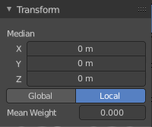
You need to have some vertices of the Lattice object selected to see the content.

Vertex
See and set the vertex positions of the lattice objects.

Global / Local
Define if the orientation of the selection is local to the selected object, or global to the world coordinates.

Mean Weight
Lattice object is a deform cage. Adjust the mean weight of the selected vertice(s).

Item tab - Transform Panel in Pose Mode
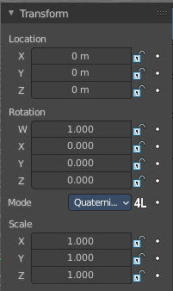

Armature Objects in Pose Mode
The content in Pose mode is the same than in Object mode. We have Location, Rotation and Scale Edit Boxes. And the corresponding lock and animate buttons.
With one small difference. The rotation mode starts with Quaternions by default. And not with Euler Angles.

Item tab - Vertex Weights Panel

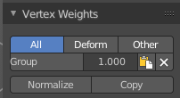
The Vertex Weights panel shows in Edit and Weight Paint mode, when you have vertices selected, and the selected vertice(s) has a weight assigned.
It allows you to modify the weight of this selected vertice(s).
In Weight paint mode you need to be in vertex selection mode and have a vertice selected. It will not show with face select mode. To select a vertice in weight paint mode hold down ctrl and click.
In Edit Mode you can select more than one vertices. In Weight Paint Mode just one vertice at a time.

Filter Vertex Groups
The first row is a setting. You can filter by all, only vertex groups that are assinged to deform bones. Or vertex groups that are assigned to non deform bones.

Group
Set as active Vertex Group.

Weight
The weight of the selected vertice(s). The range goes from 0 to 1.

Paste Weight to Selected
Copy this group's weight to other selected vertices.

Delete Weight
Deletes the weight for this selected vertice(s).

Normalize
Normalizes the weight of the selected vertice(s).

Copy
Copy active vertex to other selected vertices.

